**EE464 STATIC POWER CONVERSION – II**

**HOMEWORK – II**

**TEAM – IV**

**Group Members:**

**Göktuğ Tonay – 2305506**

**Anıl Yalçınkaya – 2376085**

**Introduction**

In this homework we designed full bridge converter. We find its required inductor capacitor values and designed its magnetic components according to specifications. We tested our circuit on Simulink and examined the result. We think this homework had prepared us for our hardware project (Especially magnetic design part).

**1)**

**a)** Current passes through transformers when Sw1 and Sw2 or Sw3 and Sw4 is closed. In one period Ts, Sw1, Sw2 and Sw3, Sw4 is closed for D*Ts amount of time separately. So in each period current passes through transformer 2*D*Ts amount of time and D can not be more than 0.5 because it will cause short circuit. Otherwise, this push pull converter works similarly to buck converter. Vs = 12V, Vo = 48V, D = 0.4 from this we can calculate turns ratio.

There is 5 secondary winding for 1 primary winding.

**b)** When D is on voltage across Lx is . D is on for DTs time. Also, from Pout = Vout*Iout = Vout*ILx (average of Iout = ILx because average current across capacitor is 0) we can find average current across inductor which is 96/48 = 2 A. Which means our required current ripple is 2*0.1 = 0.2A. From inductor formula we can find ripple current on inductor.

**c)** Average output voltage is 48 V so our required ripple is 48*0.01 = 0.48 V. Current passing through capacitor is ILx – Iout. And we can calculate capacitance by from charge formula.

ΔQc is total charge accumulated when ILx – Iout > 0. Because average of ILx is Iout total time when ILx – Iout > 0 and this is push pull converter is quarter period. ILx at peak is Iout + (Iripple /2). Which means (First ½ is because of triangular shape of ILx – Iout).

From this we can calculate required capacitance by

**2)**  
**a)** To select a core for transformer, we firstly calculate the area product formula. Required formula can be seen from application note of Mag-Inc.  
  


For P=96W, Dcma= 500, kt=0.0014, Bmax= 1200. WaAc = 0.2857.

Closest value to that are product is 3235 ER core. For lower losses R material are selected. Our final part number is 0R43225EC.

Number of primary turns van be calculated the using formula below.



By putting our values, we can find that Np≈2.06, we can round it to 2 turn.(Since we selected 0.12T, we can select a little bit lower, moreover, this will help us to have a low core loss). Then we have calculated the turns ratio from part A, our secondary turns ratio is equal to 10. Magnetizing inductance can be found by using the Al value of our core

  


**b)** To select the number of parallel conductors, We started by calculating required cross section area.



Since our mean input current is 8A, and current density is 4A/mm^2, we know that we need 2mm^2 conductor for primary, with same calculation method, we need 0.5mm^2 for secondary.

Due to skin effect, we selected to use 28AWG cables in parallel(which have 170kHz full skin depth), with that configuration our AC and DC resistance will be same. According to the page given, cross section area of 28AWG cable is, 0.080mm^2.



When we make the calculations, we need 25 parallel conductor for primary, and 7 parallel conductor for secondary.

With that configuration, fill factor can be calculated as



With that calculation, it turns out to be our fill factor is equal to 0.3541 which is bigger than 0.3 and more importantly, it is still in the usable range.

As we mentioned earlier, due to our conductor selection, our AC and DC resistances almost equal. To calculate the resistance of each winding, we firstly know the resistance value for 1mm 28AWG cable. This value can be calculated using the table given.



Next, we need to find the length of our wire to calculate the resistance, of course this will be a just an approximation, but to make a better approximation I assumed that we firstly wind primary then wind the two secondary after that. By this way we can find approximate mean radius of primary and secondary windings separately.

To calculate the end point of primary winding, we can define a fill factor for only primary winding.

metin içeren bir resim

Açıklama otomatik olarak oluşturuldu

By this formula we can learn that, only 9.32% of our winding are has used for primary winding. Then we can calculate the radius of last turn in the primary winding by using the formula below.



With that formula we can find that, that radius is equal to 13.78mm, then we can assume that (12.4+13.78)/2 is our mean radius and calculate the resistance.



With the same process we can calculate the secondary as



Copper losses are simple I^2R losses and can be calculated as follows.



For the secondary part, we should firstly calculate the current value,

metin içeren bir resim

Açıklama otomatik olarak oluşturuldu

Then





**c)** Calculation process of core loss is not simple, to make it simple manufacturer gives us a excel sheet, by using that excel sheet we can approximate our core loss.

tablo içeren bir resim

Açıklama otomatik olarak oluşturuldu

Figure 1. Core loss approximation using manufacturers excel sheet

As can be seen from figure above, manufacturer gives us a approximate loss for unit volume. We know from our cores datasheet that, our effective volume is equal to 5.4cm^3, then our total core loss is equal to



Core loss is much higher than copper losses. For our transformer, core losses will be dominate.

**d)** For the inductor design process, we decided to use toroid core rather then selecting a E core and calculating the air gap. Design process of Mag-Inc is a quite detailed process; however, it needs iterations. After some iterations we decided to use 60µ cores are suitable for us. Selection of size is completely iterative process, due to restrictions on fill factor.

After some iterations we found that 0077059A7 toroid from Mag-Inc is a good solution for us. Number of turns can be calculated as follows.

metin içeren bir resim

Açıklama otomatik olarak oluşturuldu

If we directly calculate the value for given Al, then we can find we need 74.7 turns, we must round it to 75 turn. Then we can check the DC bias curve, which is given below.

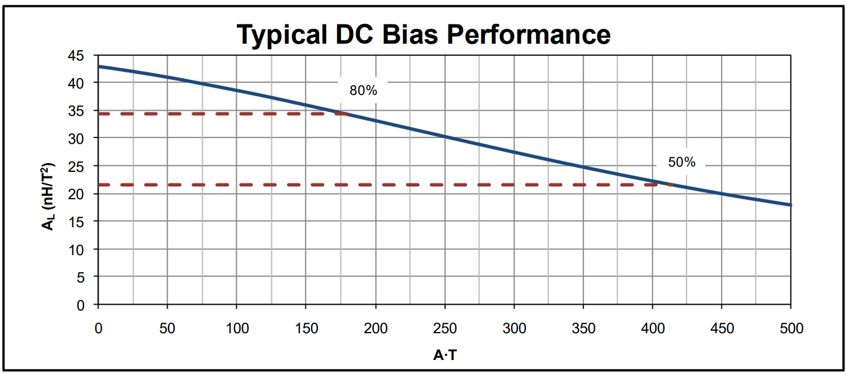  
Figure 2. DC bias curve of selected toroid

As can be clearly seen that for our values(75turn*2A) Al value almost dropped the 80% of initial value, that means that our inductance is not equal to what we want at our operating point. To solve that problem lets make our calculations again with assuming that our Al=35 from beginning.



Now our current turn number is equal to 83, and even in the our operating region our inductance value is equal to approximately 248µH.

**e)** Winding design process pretty much same as the transformer, from the current density we know that we need 0.5mm^2 conductor cross section area. Moreover, our output ripple frequency is double of switching frequency, that means that we need to select thinner conductors to get rid of skin effect. For that reason, we selected 30AWG cable, which as 270kHz skin depth. Cross sectional area of 30AWG cable is equal to 0.0507mm^2, then it is suitable to use 10 parallel conductors.

metin içeren bir resim

Açıklama otomatik olarak oluşturuldu



Our fill factor satisfies the requirements.

For the calculation of resistance, we can refer to datasheet, for length of each turn.

tablo içeren bir resim

Açıklama otomatik olarak oluşturuldu  
Figure 3. Length of each turn with different winding factor

As can be seen from Figure 2.3, our mean length is equal to 32mm for each turn, moreover we can calculate the resistance of 30AWG cable per millimeter using given table as







**f)** To calculate the core loss, we can again refer to manufacturer’s documents.

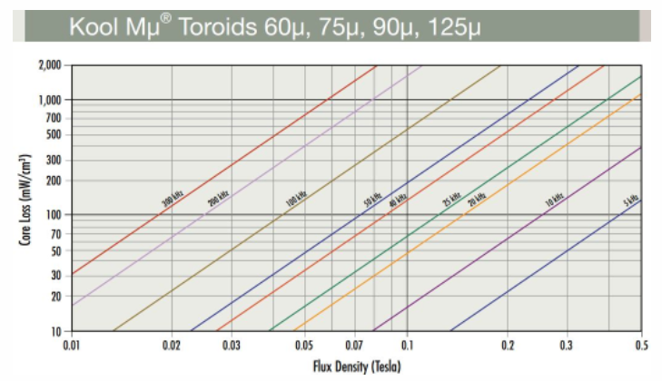  
Figure 4. Core loss parameters from manufacturers material sheet

Core loss is about the change in the flux density, that means that we should calculate the delta B value using our ripple current.



Since we designed our inductor to satisfy 0.2A ripple, I will take , we calculated the N previous parts, due to dc bias characteristics we take Al=35nH/N^2 and cross section area of core can be found on datasheet.



From the Figure 2.4 at 200kHz, 0.2T change creates loss of approximately 60mW per cm^3, volume of our core is equal to 1.8cm^3, then total core loss equal to 108mW.

For our inductor, core loss is less than copper losses, this is mainly due to DC current cannot create core loss but create copper loss, and most of our current is DC.

**3)**

**a)** Waveforms of asked values are given in figures 5. 6. 7. 8. and 9. Also while making the MATLAB simulation I took semiconductors as ideal devices. Only unitalities come from winding resistances of transformer and resistance of inductor.

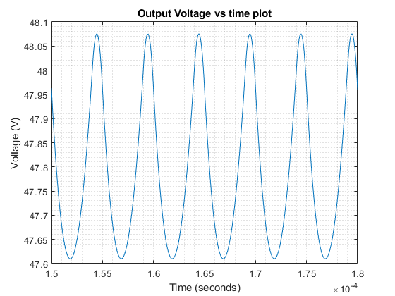

Figure 5. Vo plot

From figure 5. we can see that average output voltage is 47.84 V which is slightly smaller than our 48 V value, but we can say it fits our specifications because difference is small. This is caused by voltage drop at inductor. Voltage ripple is %0.972 which smaller than our required %1 value.

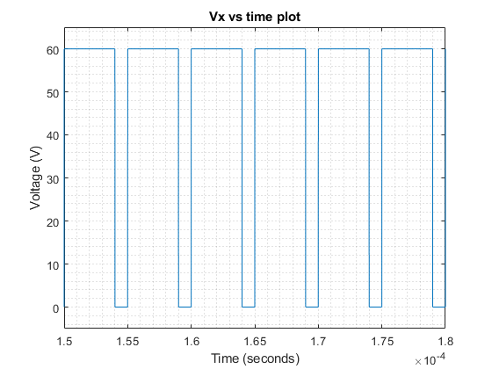

Figure 6. Vx plot

Vx plot is as expected. Vx is 60V when Sw1 and Sw2 or Sw3 and Sw4 is on because transformer conducts, and 60 V is input voltage multiplied by turns ratio. Vx is 0 when they are off because transformer does not conduct. Alsa 60V means that rated voltage of our diode must be at least 60V.

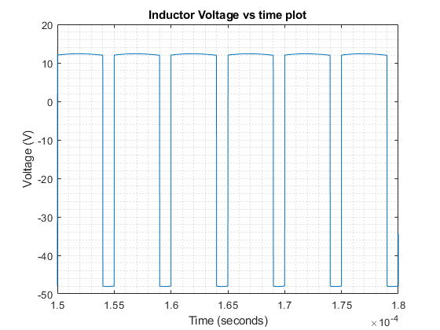

Figure 7. VL plot

VL plot is as expected. VL is around 12 V when D is on and -48V when D is off. This is expected because 12 equals to Vin * turns ratio – Vo and -48 equals to Vo. Also this means rated voltage of inductors must be at least 48V.

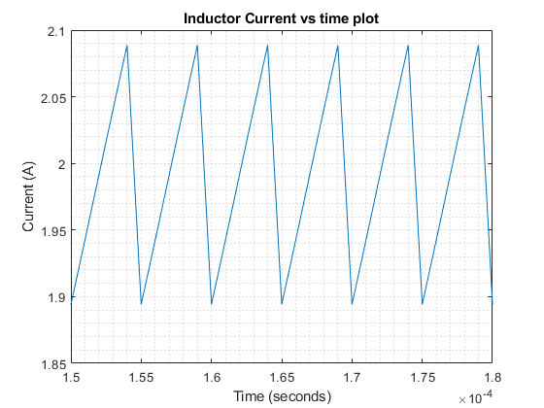

Figure 8. IL plot

Average inductor current is 1.992A which is equal to output current. We expected output current to be 2A but because difference is small, we can say it fits our specification. Difference is caused by resistance of transformer windings and inductor. Current ripple is %9.74 which smaller than our %10 limit. Also our inductor must have current rating of at least 2.1A because of ripple current.

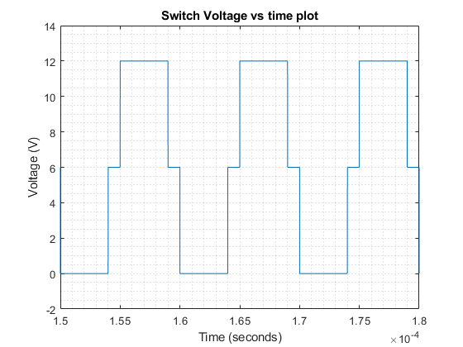

Figure 9. Vsw1 plot

Switch voltage 1 is 0 when Sw1 is closed as expected because MOSFET is conducting (I took MOSFET as ideal). Switch voltage 1 is 6V when all switches are closed because voltage is shared between sw1 and sw2 (This is only the case only in ideal MOSFET). When Sw1 is open and sw2 is closed Vsw1 is 12 because bottom of sw2 is 0 V and top of sw1 is 12V. From these we can conclude we need at least 12V rated MOSFET also we need at least 8A rated MOSFET because input current is 8A.

**b)** Leakage inductance is caused by imperfectly coupled windings. Because of leakage inductance some of magnetic field induced in primary will not reach secondary so induced voltage at secondary will be smaller than expected. This will increase the losses and reduce the output voltage and current. In order to reduce leakage inductance, we can use interleaved windings with minimum insulation. Also, in order to make output voltage our desired value we can increase duty cycle slightly taking leakage inductance into account.

**c)** Inductor will be charged for slightly longer duration when D = 0.401 and it will be charged for slightly shorter duration when D = 0.399. So inductor current and output voltage peaks will be slightly higher when D = 0.401 and this will increase the ripple values and our output voltage and current values will be distorted. In order to prevent that we can place closed loop system that controls D values using microcontroller. We can also phase shift by duty cycle of sw1 and sw2 by half period to achieve duty cycle of sw3 and sw4. This way their D values will be same.